Chibitronics Case Study 6 year olds-11 year olds
Duke School Summer Camp
Durham, North Carolina
Summer, 2016

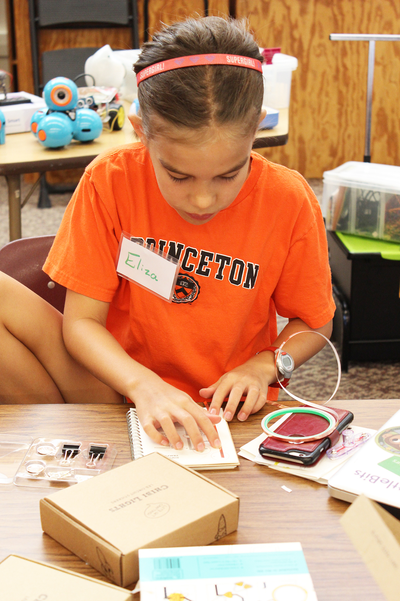

Age Group: 6-11 year old students

Group Size: 4-6

Session Leader: Susan Wells

ACTIVITY
Chibitronics Chibi Lights LED Circuit Sticker STEM Starter Kits were used, in 30-minute sessions, to provide authentic experience in design, creation, and design thinking with circuitry. It involved such skills as working in a group, sharing, communicating effectively, following directions, developing spatial awareness, and general problem solving.
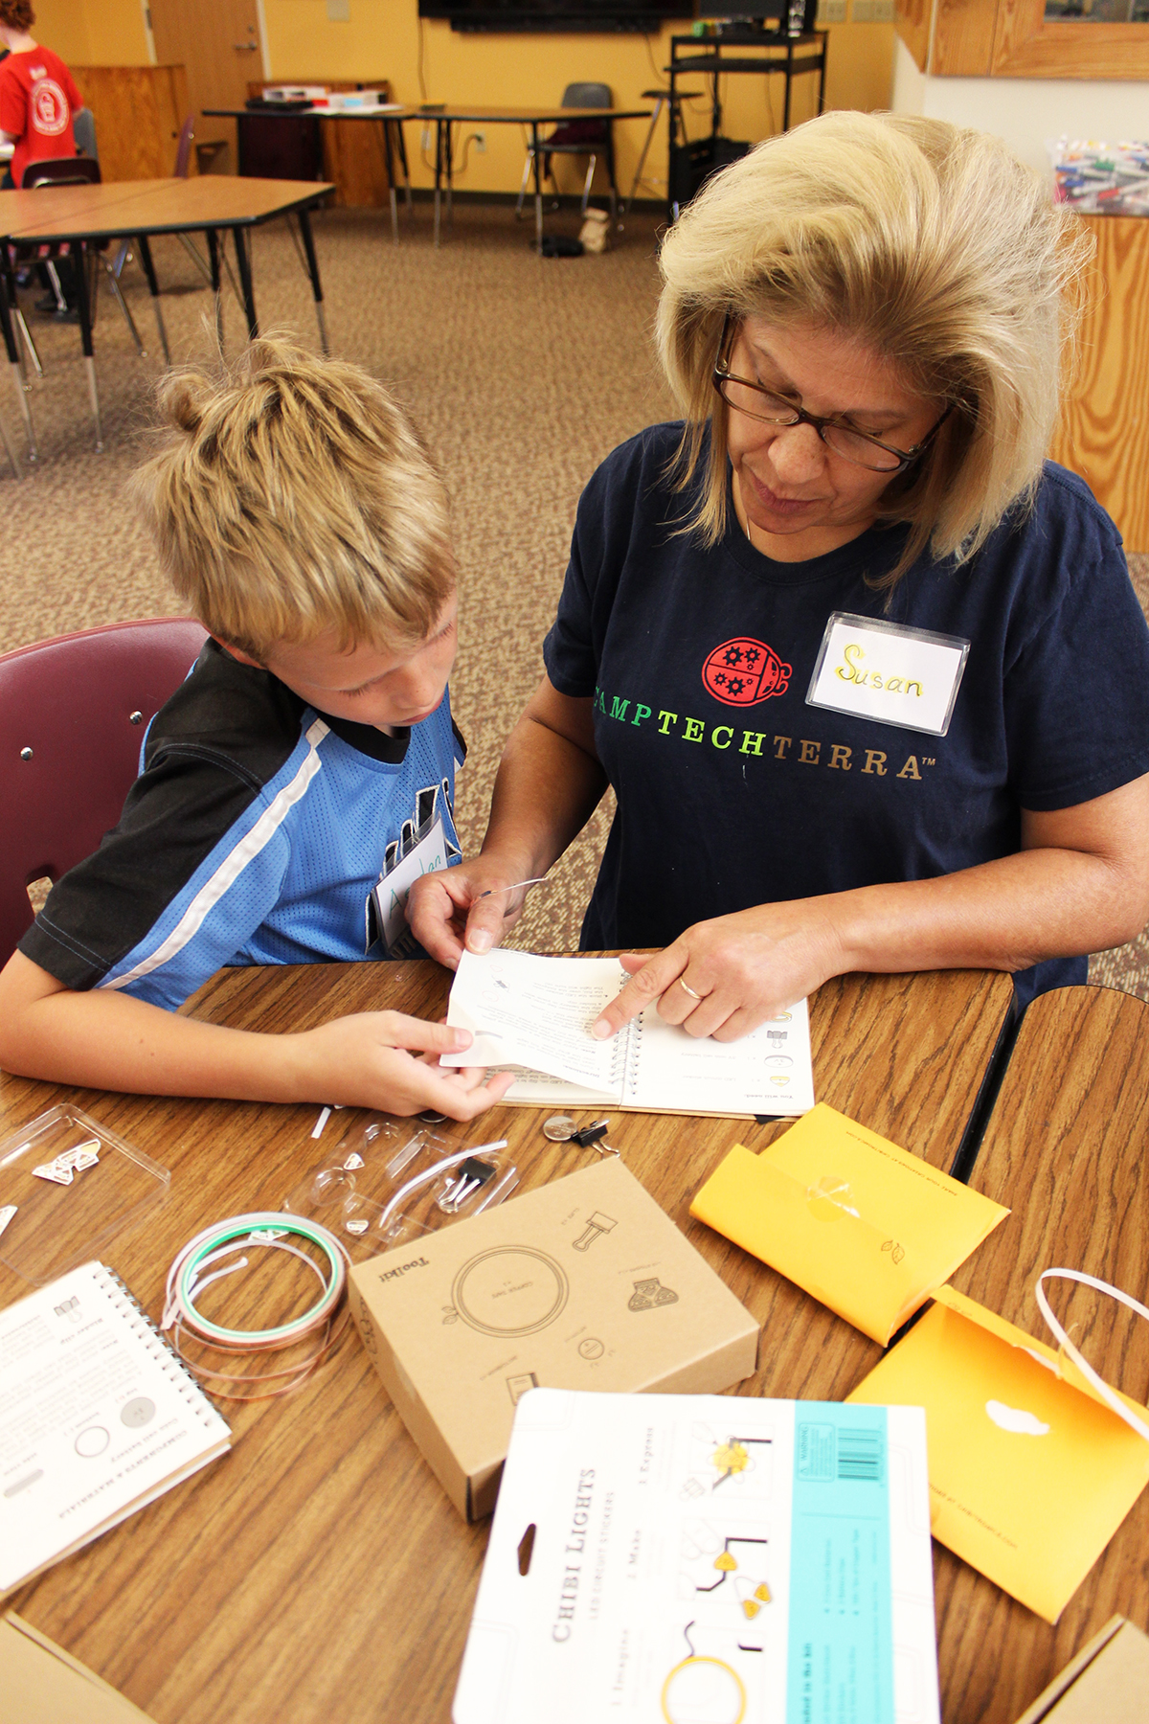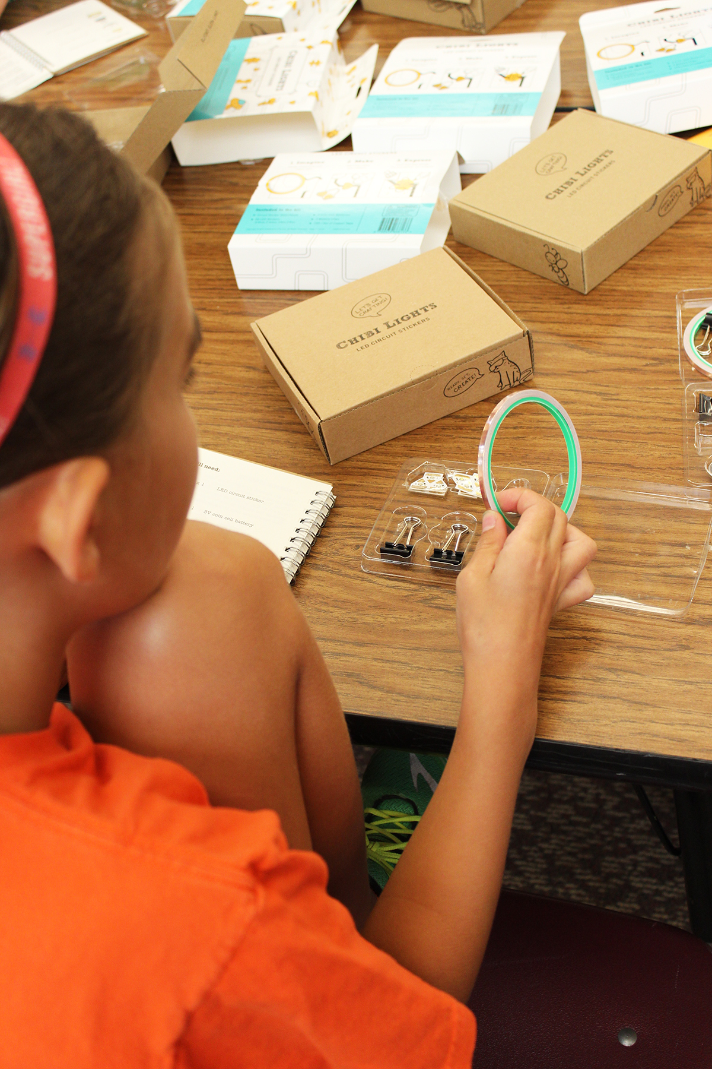

HOW WERE CHIBITRONICS USED?
Chibitronics circuit stickers were used to teach authentic creation and use of electricity and circuit design. Some students had explored Snap Circuits and littleBits prior to this lesson. Each group member worked independently on a simple circuit creation. They subsequently worked collaboratively to support each other in creating parallel and serial circuits.

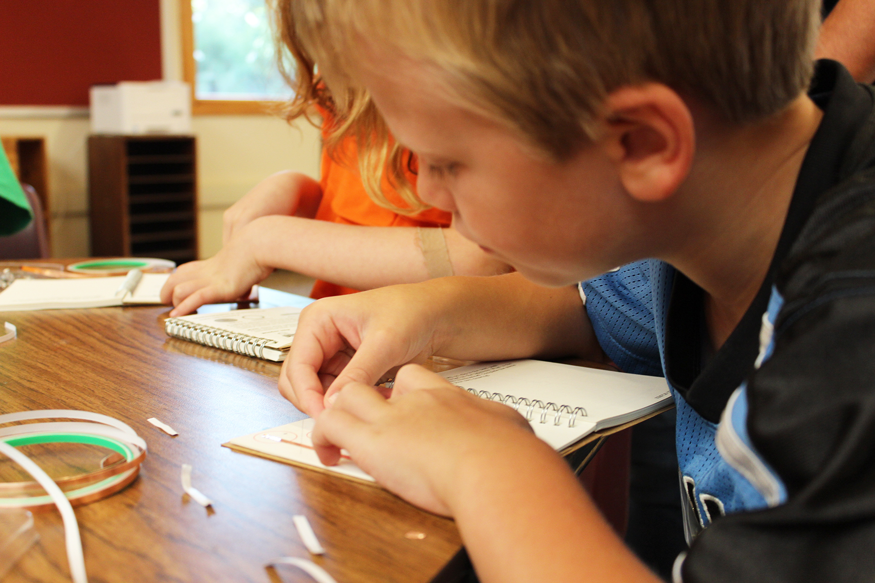

WHAT WORKED BEST?
Teacher referred to the tutorials and videos found on the Chibitronics website to introduce the work. This allowed for sound foundational understanding and an ability to get started and work with some independence.
Group size was successful for high effectiveness and high engagement.
The ability for students to physically manipulate their tape and stickers influenced attention, focus and success.
The ability to personalize their creations with art led to persevering through de-bugging their circuits.

WHAT WAS CHALLENGING?
Corners and turns with the copper tape were challenging for the smallest hands. Practicing with the copper tape alone, without power or circuitry, was helpful. When we moved to connecting with LED stickers and coin batteries students had significantly increased successful manipulation of the copper tape.
Battery placement and effective connectivity was challenging. With practice all students succeeded in constructing working circuits.

HOW DID STUDENTS RESPOND?
The students were completely engaged. They enjoyed the tangible nature of the Chibitronics kits. Students reported that they had “learned circuits in school from the board but it didn’t make sense”. All students reported excitement at their success and at their new understanding.

HOW DID THE STAFF RESPOND?
Prior to starting the kits all staff members were trained in the sticker and tape use. They all reported loving the activity and many said that this was the first time they really got the circuitry concept. The teaching staff was very impressed with student engagement, problem solving, and time on task. The website videos were clear and the materials easy to use. Chibitronics was an effective learning tool for students with a wide variety of learning styles and abilities.

